APPENDIX A

Location Plan

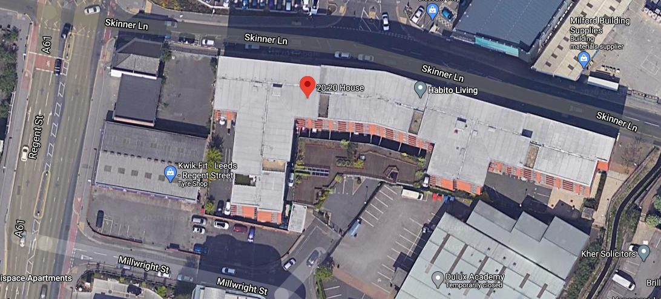
Courtesy of Google Maps

